Cornea 20(8): 811-815, 2001. © 2001 Lippincott Williams & Wilkins, Inc., Philadelphia

Comparison of Fluorescein Break-Up Time Measurement Reproducibility Using Standard Fluorescein Strips Versus the Dry Eye Test (DET) Method

Donald R. Korb, O.D., Jack V. Greiner, D.O., Ph.D., and John Herman, O.D.

Purpose. To compare the repeatability of fluorescein break-up time (FBUT) measurements determined with either a standard fluorescein strip or the Dry Eye Test (DET) modified fluorescein strip methods. Methods. This was a prospective, randomized contralateral study of 100 patients, in which FBUT measurements were determined with a standard FUL-GLO fluorescein strip (Akorn, Inc., Buffalo Grove, IL, U.S.A.) in one eye and a DET strip (Akorn, Inc., Buffalo Grove, IL, U.S.A.) for the contralateral eye. Three consecutive measurements were made immediately after fluorescein instillation. The second eye was evaluated 1 minute after completion of the first eye. Data from patients with FBUT values less than 20 seconds were included in the data analysis, because measurements greater than 20 seconds are not diagnostically significant. Results. Seventy-five patients met enrollment and FBUT measurement criteria. For three consecutive FBUT measurements, the DET values were within 3 seconds for 72 of the 75 patients (96%). Eighty percent of patients reported no sensation with the DET strip, 20% reported mild sensation. and no patient reported moderate sensation, With FUL-GLO strips, measurements were within 3 seconds for 53 of the 75 patients (71%) (p < 0.005). The standard fluorescein strip method elicited reports of no sensation from 31% of patients, mild sensation from 60%, and moderate sensation from 9% (p < 0.001). Conclusions. The DET strip provides a significant reduction in sensation upon application, improved single measurement reliability, and enhanced measurement precision, compared with a conventional fluorescein strip.
Key Words: Fluorescein break-up time (FBUT)—DET method—Fluorescein strips—

Compromised tear film stability is a common feature among conditions causing ocular irritation.^{1,2} To date, the only clinically applicable method of measuring tear film stability is break-up time (BUT), defined as the time interval between a blink and the first occurrence of gaps or breaks in the tear film. The clinical relevance of this test has been emphasized by the recommendation of the National Eye Institute/Industry Workshop on Clinical Trials in Dry

Submitted February 21, 2001. Accepted June 14, 2001.
From Ocular Research of Boston, Boston, Massachusetts, U.S.A.
(D.R.K.); Department of Ophthalmology, Harvard Medical School and Schepens Eye Research Institute, Boston, Massachusetts. U.S.A. (J.V.G.); and Pittsfield Eye Associates, Pittsfield, Massachusetts, U.S.A, (J.H.)
Address correspondence and reprint requests to Dr. D.R. Korb, 100 Boylston St, Boston, MA 02116, U.S.A. E-mail: drk@aol.com

Eyes that a “test of tear stability (BUT) be used as a global criterion of dry eye.”³
Although invasive and noninvasive methods are available for evaluating BUT. the method most commonly used by leading practitioners in the field of dry eye is fluorescein break-up time (FBUT).⁴ This procedure involves the introduction of fluorescein to the tear film, generally through the use of a moistened fluorescein strip. Despite the acknowledgment of its value in establishing a diagnosis of dry eye, FBUT has been criticized by some. Specifically, the test has been variously labeled as inaccurate, unscientific, and not reproducible.⁵⁻⁹ Such labels are reinforced by the discrepancies in values reported as “normal,” ranging from 3 to l00 seconds,^{5,10-12} although the generally accepted cut-off point for abnormal FBUT values is less than l0 seconds.^{11,13-15} Furthermore, the lack of a standardized procedure for moistening and applying the fluorescein strip to the tear film presents a source of variability in test results among investigators. In particular, there is no agreement as to whether the moistened strip should be shaken before instillation^{7,10,16,17} or whether the strip should be applied to the superior,¹⁶ inferior,^{5,10} temporal,⁷ or inferior temporal² bulbar conjunctiva, or to the tear meniscus.¹⁷
Perhaps the greatest source of variability in FBUT values relates to the volume of fluorescein delivered to the tear film environment. Fluorescein break-up time measurement reliability is increased when 2 µL or less of a 5% fluorescein solution is applied with a laboratory micropipette versus the conventional strip method.⁷ Although the volume of fluorescein solution actually delivered by the conventional strip method has not been reported, an approximate value can be extrapolated from data regarding commercially available rose bengal impregnated strips.^{l8} In this case, 17.43 ± 3.09 µL of fluid is delivered after the rose bengal strip is moistened with 2 drops (100 µL ) saline, and the excess saline is allowed to fall off the strip by gravity. Given the similar physical dimensions of the two strips, it is reasonable to assume that the fluorescein strip would have the potential for delivering a similar amount of fluid to the tear film. The potential disruptive effect of this volume on the tear film can be appreciated when one considers that the total volume of the tear film is 7 µL .¹⁹⁻²¹
Although laboratory micropipettes offer a precise method for the instillation of µL quantities of fluorescein, the use of fluorescein solutions in the clinical setting is not practical because of issues of potential contamination of stock solutions. To reduce the volume of fluid introduced to the tear film as a necessary part of FBUT measurements, a modified fluorescein strip, Dry Eye Test (DET) (Akorn, Inc.), was recently developed for the delivery of 1 µL of fluorescein solution in a clinically feasible manner, and without perceived sensation on the part of the patient.^{22,23} The physical dimensions of the DET strip are 1 mm in width and 10 mm in length, in contrast with the most commonly used fluorescein strips that are either 5 mm by 15 mm (Fluorets, Chauvin Pharmaceuticals, Ltd, Romford, Essex, UK), or 5 mm by 10 mm (Barnes Hind FUL-GLO, Akorn, Inc., Buffalo Grove, IL) (Fig. 1A). The current study examines whether the design modifications of the DET strip and its application methodology translate into an increase in the repeatability of FBUT measurements over that offered by the conventional fluorescein strip.

MATERIALS AND METHODS

A prospective, randomized contralateral study design was used at three separate study sites. A total of 100 consecutive patients reporting for ocular examination and meeting the inclusion/ exclusion criteria were enrolled—34 at one site and 33 each at the remaining sites. Inclusion criteria included: 1) an age range from 20 to 59 years; 2) normal ocular status, defined as a minimum of 20/40 corrected vision in each eye; clear corneas without scarring, opacities, or vascularization as determined by biomicroscopic examination; normal puncta without punctal plugs; and the absence of any corneal disease or dystrophy that might influence FBUT. Exclusion criteria included: 1) history of ocular surgery or corneal injury; 2) active conjunctivitis, including allergic conjunctivitis; 3) conjunctival abnormality other than mild pinguecula; 4) current ocular infection or treatment of such infections with ocular or systemic agents; 5) current use of any ocular medication, including antihistamines; 6) use of artificial tear preparations 2 hours prior to examination; 7) use of any ocular ointment, swimming in chlorinated water, or contact lens wear 24 hours prior to examination, 8) a diagnosis of Sjogren's disease; 9) anisometropia of more than 3.00 diopters; and 10) any report of ocular pain. Symptoms of ocular dryness and the use of systemic antihistamines, diuretics, tranquilizers, and other medications were not reasons for exclusion. Informed consent was obtained from each patient, after the nature of the study was explained. Patients were randomized as to the eye and type of fluorescein strip that would be evaluated initially.
Prior to use, a standard fluorescein strip (Barnes Hind FUL-GLO strip, Akorn, Inc.) or a DET strip (Akorn, Inc.) was wet with one drop of Unisol 4 (Alcon Laboratories, Fort Worth, TX). Care was taken to avoid applying the Unisol to the fluorescein strip holder. The FUL-GLO strip (Akorn, Inc.) was gently shaken once after Unisol 4 (Alcon Laboratories) moistening to remove excess fluorescein solution from the strip. The DET strip (Akorn, Inc.) was not shaken after wetting, as directed by the package insert recommendations (Fig. 1B). The patient was instructed to look down and nasally, with the patient's index finger being used as a fixation target to prevent patient observation of the application of the fluorescein strip. The examiner gently retracted the upper lid while patient continued to fixate down and nasally. The fluorescein strip was introduced at an approximate 30-degree angle and then touched to the superior temporal bulbar conjunctiva, preferably 5 mm or more from the limbus, for 1 second, so that 1-2 mm of the flat side made contact with the ocular surface. The strip was then withdrawn (Figs. 2A,B). In those cases in which the size of the FUL-GLO strip (Akorn, Inc.) prevented application to the desired position on the superior temporal bulbar conjunctiva, the strip was alternatively applied to a location on the bulbar conjunctiva as close as possible to the preferred position (Figs. 2C,D). Immediately after application, the patient was asked to report whether sensation had been experienced and, if so, whether the sensation could be described as mild, moderate, or severe. Patients were presented with guidelines for sensation classification as follows: mild-aware, without specific sensation; moderate-definite sensation without discomfort; severe-unpleasant sensation. After the application of either strip and the release of the upper lid, the patient was requested to blink three times naturally, open, then

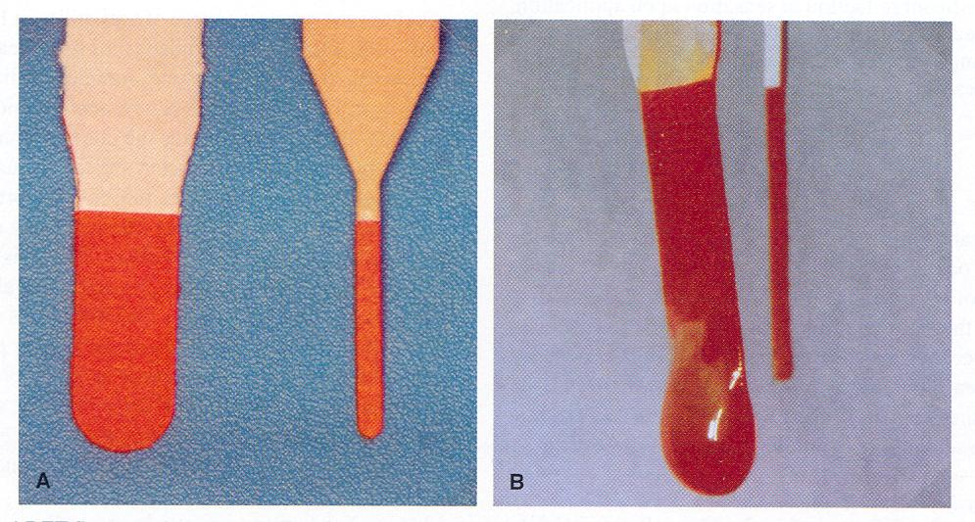

FIG. 1. FUL-GLO and DET fluorescein strips. A: The fluorescein impregnated portion of a standard fluorescein strip (Barnes Hind FUL-GLO, Akorn, Inc., Buffalo Grove, IL) is 10 mm in length and 5 mm in width. The fluorescein impregnated portion of the modified fluorescein strip (DET, Akorn, Inc., Buffalo Grove, IL, U.S.A.) is 10 mm in length and 1 mm in width. B: After application of 1 drop of Unisol 4 to the FUL-GLO strip, a droplet of 30-50 µL of solution is formed. The removal of the excess solution requires shaking the strip. However, the amount of solution removed by shaking is variable. After an identical application of one drop of Unisol 4 to the DET strip, the surfaces are wet, but no droplet is formed, allowing the application of a controlled dose.

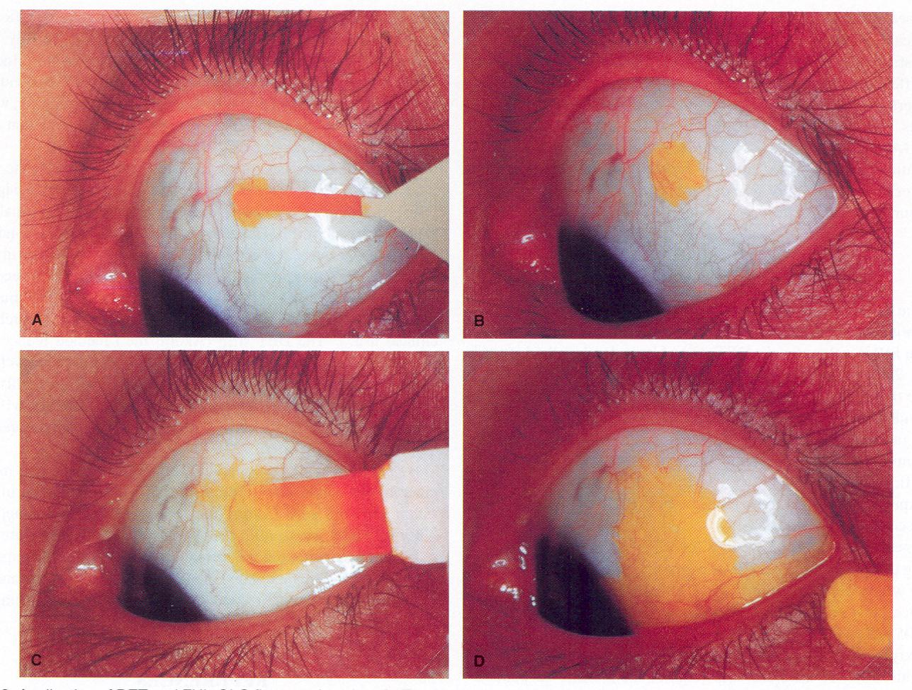

FIG. 2. Application of DET and FUL-GLO fluorescein strips. A: Fixation is directed inferonasally, and the upper lid is gently retracted. The DET strip is then introduced at an approximate 30° angle to the superior bulbar conjunctiva and touched for 1-2 seconds, so that 1-2 mm of the flat side makes contact. Preferably, the contact area should be 5 mm or more from the limbus. B: A 3-4 mm² area of fluorescein remains on the bulbar conjunctiva after the withdrawal of the DET strip. This represents the desired application and corresponds to a volume of approximately 1 µL of fluorescein solution. C: The standard FUL-GLO fluorescein strip is touched to the superior temporal bulbar conjunctiva by using the same technique as for the DET strip. The excess solution had been removed by gentle shaking before application. D: Fluorescein is present on the majority of the ocular surfaces after withdrawal of the standard FUL-GLO fluorescein strip. The amount of fluorescein delivered in this manner varies between 7 and 15 µL.

refrain from blinking. The fluorescein break-up was then observed with a Haag Streit 900 slit lamp (Haag Streit, Bern, Switzerland) with a cobalt blue filter transmitting 330 to 400 nm and a beam approximately 4-mm wide and l0-mm high. The lowest level of illumination was used. The beam was moved from side to side to cover the entire cornea.^{10,12} Tear film break-up was defined as the first observed break-up of the tear film following the third blink. A stopwatch was used to measure the FBUT. After the first measurement, the patient was instructed to blink naturally three additional times, and a second measurement of FBUT was recorded. This procedure was repeated for a third FBUT measurement. All measurements were terminated at 20 seconds to prevent possible corneal drying and other phenomena that might interfere with the subsequent measurements. After a 60-second rest period and the completion of measurements on the first eye, FBUT values were determined on the contralateral eye with the alternate strip, using this same procedure.
Patients were dismissed from the study if excess tearing was noted, or adequate fluorescein was not present for all three measurements. These patients were excluded from the enrollment quota at all three sites. Additionally, data from patients exhibiting measurements of 20 seconds or greater were excluded from analy-

TABLE 1. Maximum variation in seconds between 3 consecutive FBUT measurements*

 | Equal | 1s | 2s | 3s | 4s | 5s | 6s | 7s | 8s | 9s | 10s
DET
% of 75 subjects | 22% | 41% | 19% | 14% | 1% | 1% | 1% | 1%
FUL-GLO
% of 75 subjects | 8% | 35% | 20% | 8% | 11% | 7% | 3% | 4% | 3% |  | 1%
*Data from subjects exhibiting measurements 20 seconds were excluded from analysis.

-sis, because FBUT values greater than 20 seconds are not diagnostically significant.
Statistical analyses included the paired t test for determination of difference between the means, a McNemar's test of correlated proportions to determine the reproducibility of FBUT measurements with the DET (Akorn, Inc.) and the standard fluorescein strip (Akorn, Inc.), and a _{X}² statistic to examine whether perceived sensation was the same between the two FBUT methods. Measurement reproducibility was defined as three consecutive FBUT measurements within a 3-second range.

RESULTS

Due to FBUT measurements greater than or equal to 20 seconds, 25 patients were dismissed from the study for a final n value of 75. Mean FBUT values for the DET strip (Akorn, Inc.) method ranged from 2.0 to 18.33 seconds for individual patients, with a mean value of 7.56 for all patients in this group. Mean FBUT values for individual patients using the standard fluorescein strip (Akorn, Inc.) ranged from 2.33 to 17.33, with a mean value of 7.35 for all patients in this group. These differences were not statistically significant.
Expressed in terms of the range of FBUT values obtained from three consecutive measurements, the DET strip (Akorn, Inc.) measurements were within 3 seconds for 72 (96%) of the 75 patients. Using the standard FUL-GLO strip (Akorn, Inc.), the FBUT values were within 3 seconds for 53 (71 %) of the 75 patients. This difference between the two methods was statistically significant (p < 0.005) (Table 1).
Sixty of the 75 patients (80%) reported no sensation during administration of the DET strip (Akorn, Inc.), while 15 patients (20%) reported a mild sensation. There were no reports of moderate sensation using the DET strip (Akorn, Inc.). Twenty-three of 75 patients (31%) reported no sensation during FUL-GLO strip application, 45 patients (60%) reported mild sensation, and 7 (9%) reported moderate sensation. There were no reports of severe sensation with either method (Table 2). These results were statistically significant (p < 0.001).

DISCUSSION

The DET strip (Akorn, Inc.) represents a major improvement in the clinical determination of FBUT values, in that a single measurement with the DET strip (Akorn, Inc.) is more reliable than a similar measurement using the standard fluorescein strip (Akorn, Inc.) method. This introduction of single-measurement reliability to the FBUT methodology eliminates the averaging of multiple, consecutive FBUT measurements, a practice often used to improve the reliability of measurements when using standard fluorescein strips.^{2,5,10,11,17} This improvement in measurement precision with the DET strip (Akorn, Inc.) may be a function of two related

TABLE 2. Sensation upon application of DET and FUL-GLO fluorescein strips

Test strip | No  sensation | Mild  sensation | Moderate  sensation | Severe  sensation
DET | 80% | 20% | 0% | 0%
FUL-GLO | 31% | 60% | 9% | 0%

factors. First, the DET strip (Akorn, Inc.) introduces significantly less fluid to the tear film and thus in essence is relatively “less invasive” than the conventional fluorescein strips (Akorn, Inc.) in terms of potential disruption of tear film integrity. Second, the DET strip (Akorn, Inc.) elicits less sensation on application, which reduces the potential for reflex tearing, and the error that such tearing can introduce to FBUT measurements.
The degree of measurement precision associated with the DET strip (Akorn, Inc.) method carries considerable clinical significance. Patients are typically categorized as “dry,” “marginal,” or “normal” based on FBUT values of 1-5 seconds, 6-9 seconds, or 10 seconds or more, respectively. Clearly, large variations in consecutive FBUT measurements, particularly those over 3 seconds, increase the likelihood of misdiagnosis and, in fact, such variations have been responsible for the FBUT's reputation as an unreliable clinical test.^{4,5} The DET strip (Akorn, Inc.) method reduces the degree of variability by providing a 96% confidence level that three consecutive FBUT values will be within 3 seconds. This is in contrast to the 71% confidence level that FBUT values will fall within those same parameters with the conventional fluorescein strip (Akorn, Inc.).
By providing a clinically practical method of delivering microquantities of fluorescein to the tear film with a reduction in sensation, the DET strip (Akorn, Inc.) enhances the clinical applicability of FBUT measurements by providing single-measurement reliability and increased measurement precision. These improvements in FBUT methodology should foster greater acceptance of this technique among clinicians for evaluation of the presumptive dry-eye patient.

REFERENCES

- Holly FJ. Formation and rupture of the tear film. Exp Eye Res 1973;15:515-25.
- Pflugfelder SC, Tseng SC, Sanabria O, et al. Evaluation of subjective assessments and objective diagnostic tests for diagnosing tear-film disorders known to cause ocular irritation. Cornea 1998;17:38-56.
- Lemp MA. Report of the National Eye Institute / Industry Workshop on Clinical Trials in Dry Eye. CLAO J 1995;21:221-32.
- Korb DR. Survey of preferred tests for diagnosis of the tear film and dry eye. Cornea 2000;19:483-6.
- Vanley GT, Leopold IH, Greg TH. Interpretation of tear film breakup. Arch Ophthalmol 1977;95:445-8.
- Mengher LS, Bron AJ, Tonge SR, Gilbert DJ. Effect of f1uorescein instillation on the precorneal tear film stability. Curr Eye Res 1985;4:9-12.
- Marquardt R, Stodmeister R, Christ T. Modification of tear film breakup time test for increased reliability. In: Holly FJ, ed. The precorneal tear film in health, disease, and contact lens wear. Lubbock, TX: Dry Eye Institute, 1986:57-63.
- Mengher LS, Bron AJ, Tonge SR, Gilbert DJ. Non-invasive assessment of tear film stability. In: Holly FJ, ed. The precorneal tear film in health, disease, and contact lens wear. Lubbock, TX: Dry Eye Institute, 1986:64-75.
- Larke JR. The eye in contact lens wear, 2nd Edition. Oxford, UK:Butterworth-Heinemann, 1997: 32-3.
- Lemp MA, Hamill JR. Factors affecting tear film breakup in normal eyes. Arch Ophthalmol (Kbh) 1973;89:103-5.
- Rengstorff RH. The precorneal tear film: breakup time and location in normal subjects. Am J Optom & Physiol Optics 1974;51:765-9.
- Norn MS. Dessication of the precorneal tear film. I. Corneal wetting time. Acta Ophthalmol (Kbh) 1969;47:865-80.
- Lemp MA, Dohlman CH, Holly FJ. Corneal dessication despite normal tear volume. Ann Ophthalmol 1970;2:258-84.
- Lemp MA, Dohlman CH, Kuwabara T, et al. Dry eye secondary to mucus deficiency. Trans Am Acad Ophthalmol Otolaryngol 1971;75:1223-7.
- Norn MS. Diagnosis of the dry eye. In: Lemp MA, Marquardt R, eds. The dry eye: a comprehensive guide. Berlin: Springer-Verlag, 1992: 153,154,165-9.
- Lowther GE. Dryness, tears, and contact lens wear. Boston, MA: Butterworth-Heinemann, 1997:36-7.
- Nelson JD. Diagnosis of keratoconjunctivitis sicca. Int Ophthalmol Clin 1994;34:37-56.
- Snyder C, Paugh JR. Rose bengal dye concentration and volume delivered via dye-impregnated paper strips. Optom & Vision Science 1998;75:339-41.
- Mathers WD, Lane JA, Zimmerman MB. Tear film changes associated with normal aging. Cornea 1996;15:229-34.
- Maurice DM. The use of fluorescein in ophthalmological research. Invest Ophthalmol 1967;6:464-77.
- Maurice DM. The dynamics and drainage of tears. Int Ophthalmol Clin 1973;13:103-16.
- Abdul-Fattah AM, Bhargava HN, Korb DR, Glonek T, Greiner JV. Quantitative in vitro comparison of fluorescein delivery to the eye via impregnated strip and volumetric techniques [abstractl. Invest Ophthalmol Vis Sci 1999;40:S544.
- Korb DR, Finnemore VM, Herman JP et al. A new method for the fluorescein breakup time test [abstractl Invest Ophthalmol Vis Sci 1999;40:S544.

